
Submitted By:
Sana Arshad
Project’s Report:
Bank Management System
with ATM Simulation using Java (GUI)
Submitted To:
DecodeLabs
For the fulfillment of:
DecodeLabs Remote Internship task

Table of Contents
1. Introduction 3
1.1 Project Overview 3
1.2 Objectives 3
1.3 Scope 3
2. Tools and Technologies Used 3
3. System Design 4
3.1 Database Tables 4
3.2 Application Flow 4
4. System Modules 4
4.1 Login Module 4
4.2 Sign Up Module 5
4.3 Main Dashboard 5
4.4 Deposit Module 5
4.5 Withdrawal Module 6
4.6 Fast Cash Module 6
4.7 Balance Enquiry Module 6
4.8 Mini Statement Module 7
4.9 PIN Management Module 7
5. Key Code Snippets 7
5.1 Database Connection (Connn.java) 7
5.2 Withdrawal Logic with Balance Check (Withdrawl.java) 8
5.3 PIN Update Across Tables (Pin.java) 8
6. Testing 9
7. System Architecture 9
8. Conclusion 10

1. Introduction

1.1 Project Overview
- AL-YUSR Digital Banking System is a desktop banking application built in Java.
- It simulates core banking operations such as account opening, login, deposits, withdrawals, balance enquiry, and PIN management.
- The application uses a graphical user interface built with Java Swing and stores data in a MySQL database.

1.2 Objectives
- To digitize basic banking operations through a simple, easy-to-use desktop interface.
- To allow new customers to open an account through an online application form.
- To allow existing customers to securely log in using a card number and PIN.
- To allow customers to deposit, withdraw, and check their account balance.
- To maintain a transaction history (mini statement) for every customer.

1.3 Scope
- The system covers customer registration, authentication, and core teller operations (deposit, withdrawal, fast cash, balance enquiry, mini statement, and PIN change).
- It is intended as an academic / demonstration project and is not connected to a real banking network.

2. Tools and Technologies Used
- Programming Language: Java (JDK)
- GUI Framework: Java Swing (JFrame, JPanel, JLabel, JButton, JTextField, JPasswordField)
- Database: MySQL
- Database Connectivity: JDBC (Java Database Connectivity)
- Third-Party Library: JCalendar (JDateChooser) for date-of-birth selection
- IDE: IntelliJ IDEA / Eclipse (replace with the IDE you actually used)

3. System Design

3.1 Database Tables
The system uses the following main tables in the MySQL database:
- login — stores form number, card number, and PIN used for authentication.
- signupthree — stores form number, account type, card number, PIN, and facility/branch details for each registered customer.
- bank — stores every transaction as a record of PIN, date, transaction type (Deposit / Withdrawal), and amount.

3.2 Application Flow
- New User: Sign Up (3-page form) → Card Number & PIN generated → Login.
- Existing User: Login → Main Dashboard → Deposit / Withdrawal / Fast Cash / Balance Enquiry / Mini Statement / Change PIN.

4. System Modules

4.1 Login Module
- Authenticates an existing customer using Card Number and PIN.
- Provides Sign In, Clear, and Sign Up buttons.
- On successful sign-in, redirects the user to the Main Dashboard.
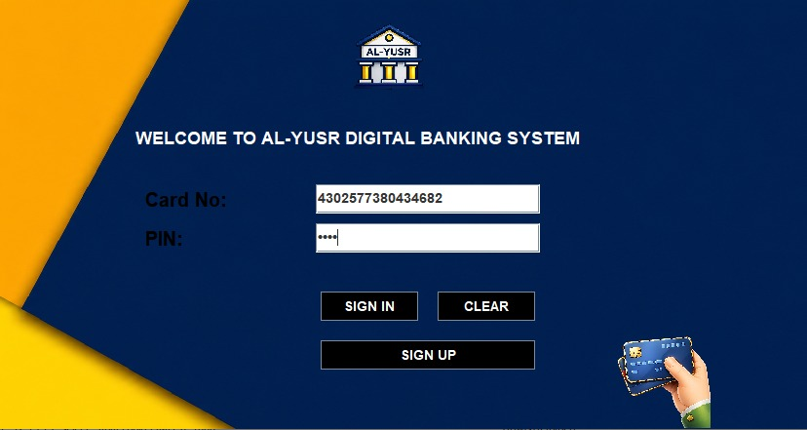

4.2 Sign Up Module
- A 3-page application form used to register a new customer.
- Page 1 collects personal details: Name, Father's Name, Date of Birth, Gender, and Marital Status.
- Page 2 collects contact details: Email, Address, City, State, and Postal Code.
- Page 3 lets the customer select an account type and generates a unique Card Number and PIN automatically.
- The generated Card Number and PIN are shown to the user and saved to the database.
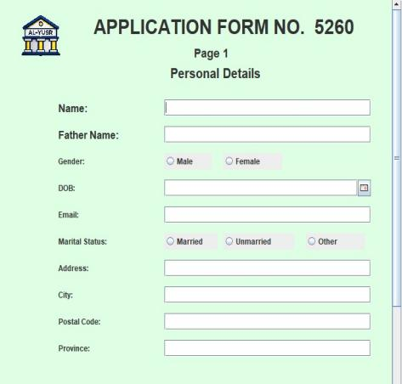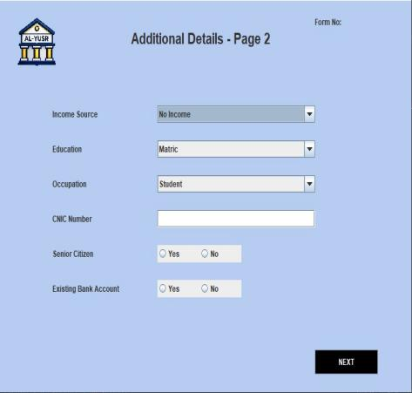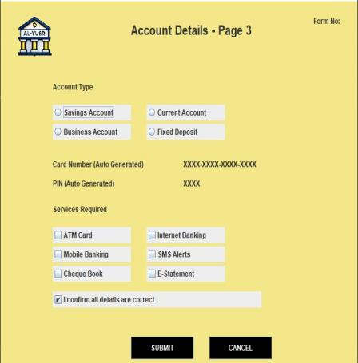

4.3 Main Dashboard
- Central menu shown after a successful login.
- Provides navigation buttons to Deposit, Withdrawal, Fast Cash, Balance Enquiry, Mini Statement, and Change PIN.

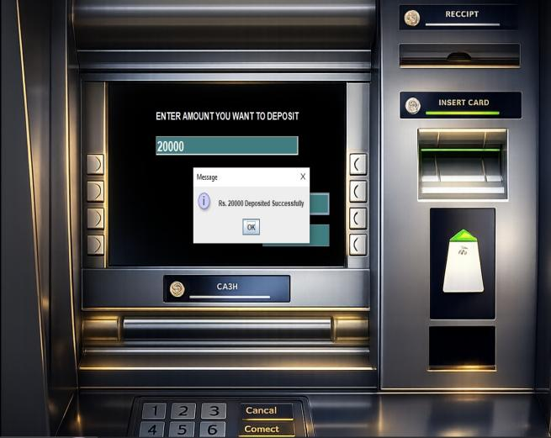
4.4 Deposit Module
- Allows the customer to enter an amount and deposit it into their account.
- Inserts a new transaction record (PIN, date, type = Deposit, amount) into the bank table.
- Returns the customer to the Main Dashboard after a successful deposit.

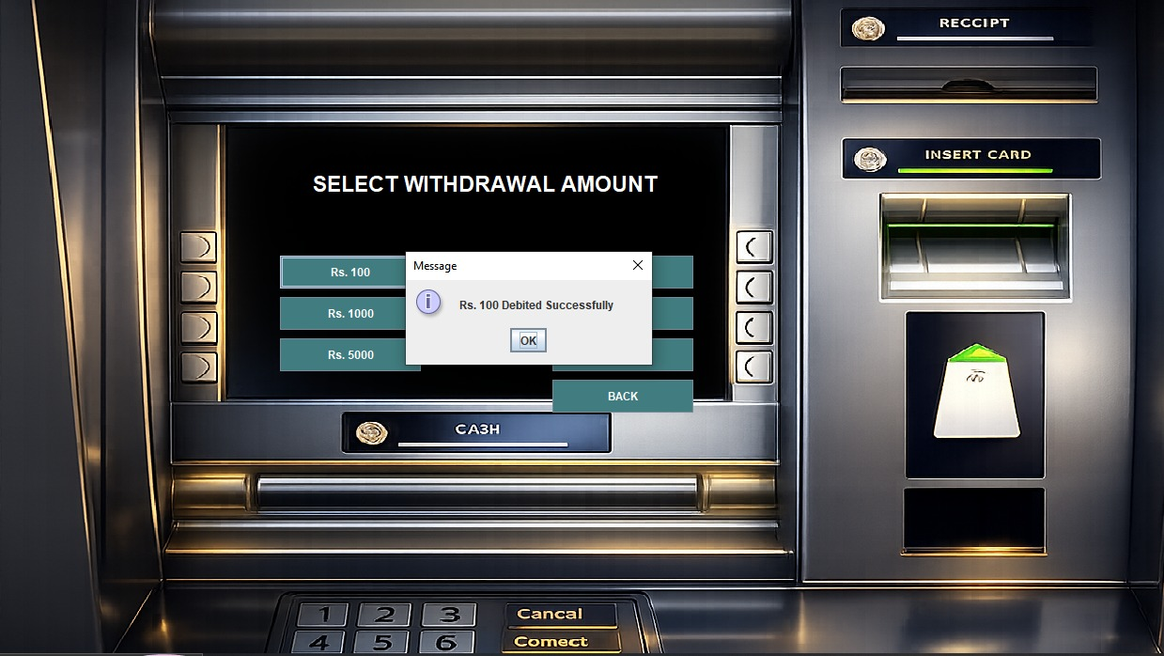
4.5 Withdrawal Module
- Allows the customer to withdraw an amount, up to a maximum limit of Rs. 10,000.
- Calculates the current balance from past transactions before approving a withdrawal.
- Rejects the request and shows an 'Insufficient Balance' message if funds are not enough.
- Inserts a new transaction record (type = Withdrawal) into the bank table on success.



4.6 Fast Cash Module
- Offers fixed quick-withdrawal amounts: Rs. 100, 500, 1000, 2000, 5000, and 10000.
- Performs the same balance check as the Withdrawal module before debiting the account.

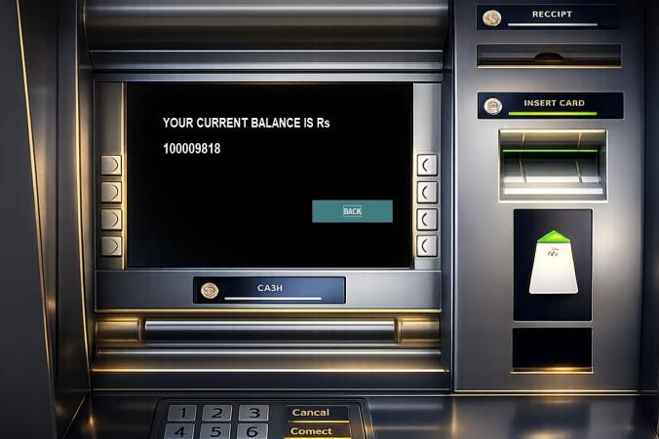
4.7 Balance Enquiry Module
- Calculates and displays the customer's current balance.
- Balance is computed by summing all Deposit transactions and subtracting all Withdrawal transactions for the logged-in PIN.

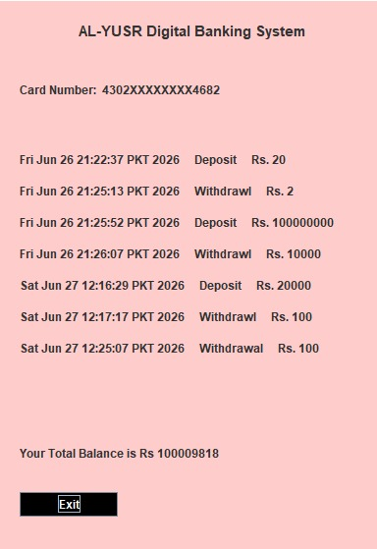
4.8 Mini Statement Module
- Displays a short transaction history for the logged-in customer: date, transaction type, and amount.
- Also displays the masked card number and the total current balance.

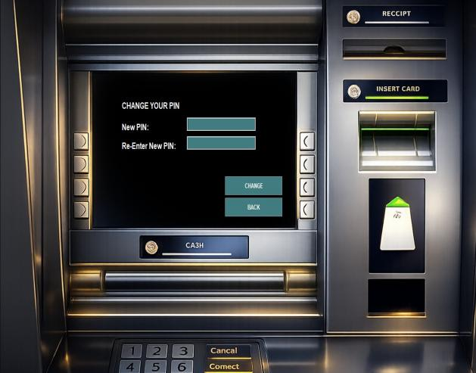
4.9 PIN Management Module
- Allows the customer to set a new PIN by entering and re-confirming it.
- Validates that both entries match before updating the database.
- Updates the PIN consistently across the bank, login, and signup three tables.

5. Key Code Snippets
A few representative code snippets are included below. The complete source code is attached separately / in the appendix.

5.1 Database Connection (Connn.java)
public class Connn {
Connection connection;
Statement statement;
public Connn(){
try{
connection = DriverManager.getConnection(
"jdbc:mysql://localhost:3306/bankSystem", "root", "password");
statement = connection.createStatement();
}catch (Exception e){
e.printStackTrace();
}
}
}

5.2 Withdrawal Logic with Balance Check (Withdrawl.java)
Connn c = new Connn();
ResultSet resultSet = c.statement.executeQuery(
"select * from bank where pin = '" + pin + "'");
int balance = 0;
while (resultSet.next()) {
if (resultSet.getString("type").equals("Deposit")) {
balance += Integer.parseInt(resultSet.getString("amount"));
} else {
balance -= Integer.parseInt(resultSet.getString("amount"));
}
}
if (balance < Integer.parseInt(amount)) {
JOptionPane.showMessageDialog(null, "Insufficient Balance");
return;
}
c.statement.executeUpdate("insert into bank values('" + pin + "', '" +
date + "', 'Withdrawl', '" + amount + "')");

5.3 PIN Update Across Tables (Pin.java)
String q1 = "update bank set pin = '"+pin1+"' where pin = '"+pin+"'";
String q2 = "update login set pin = '"+pin1+"' where pin = '"+pin+"'";
String q3 = "update signupthree set pin = '"+pin1+"' where pin = '"+pin+"'";
c.statement.executeUpdate(q1);
c.statement.executeUpdate(q2);
c.statement.executeUpdate(q3);

6. Testing
- Verified that login fails for an incorrect Card Number / PIN combination.
- Verified that withdrawal and Fast Cash requests are blocked when the balance is insufficient.
- Verified that deposit and withdrawal amounts are correctly reflected in the Balance Enquiry and Mini Statement modules.
- Verified that a changed PIN is required for the next login and old PIN no longer work.

System Architecture

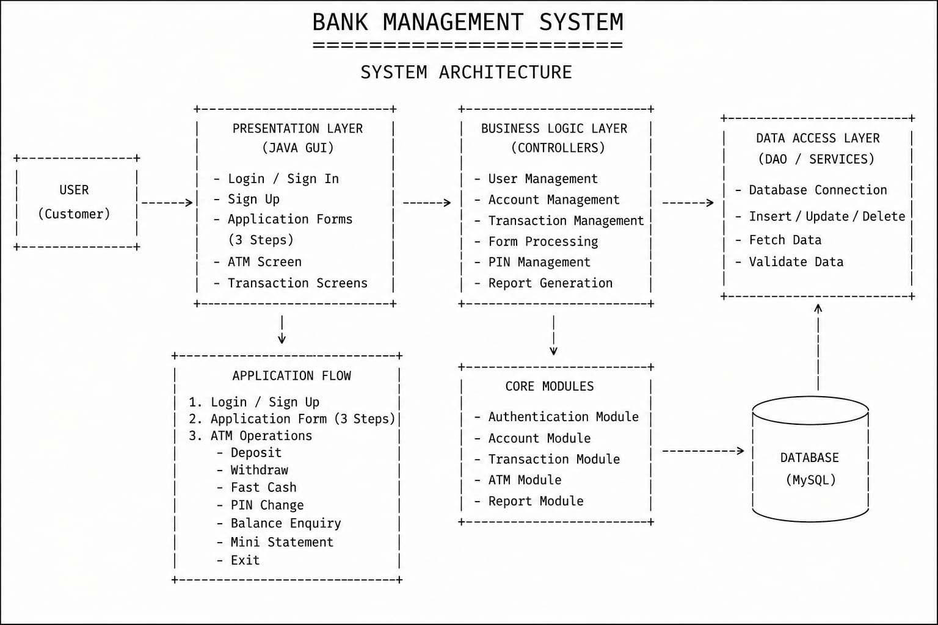

8. Conclusion
- The AL-YUSR Digital Banking System successfully implements the core features of a desktop banking application: registration, authentication, deposits, withdrawals, balance enquiry, and PIN management.
- The project provided practical experience with Java Swing GUI design and JDBC-based database connectivity.
- All planned objectives for the project were achieved.

